**DAILY ONLINE ACTIVITIES SUMMARY**

|  |  |  |  |  |  |  |  |  |
| --- | --- | --- | --- | --- | --- | --- | --- | --- |
| **Date:** | **28-06-2020** | | | | | **Name:** | **Deril Quadras** | |
| **Sem & Sec** | **8 A** | | | | | **USN:** | **4AL16CS031** | |
| **Online Test Summary** | | | | | | | | |
| **Subject** | | **-** | | | | | | |
| **Max. Marks** | | **-** | | **Score** | | | **-** | |
| **Certification Course Summary** | | | | | | | | |
| **Course** | **Understanding Placement Groups.** | | | | | | | |
| **Certificate Provider** | | | **AWS** | | **Duration** | | | **30 mins** |
| **Coding Challenges** | | | | | | | | |
| **Problem Statement:**   1. **Write a C Program to string comparision without using builtin function** | | | | | | | | |
| **Status: Solved** | | | | | | | | |
| **Uploaded the report in Github** | | | | | **Yes** | | | |
| **If yes Repository name** | | | | | **Derilquadras/online_c_coding_repository** | | | |
| **Uploaded the report in slack** | | | | | **Yes** | | | |

Online Test Details:

Not Conducted

Certification Course Details:

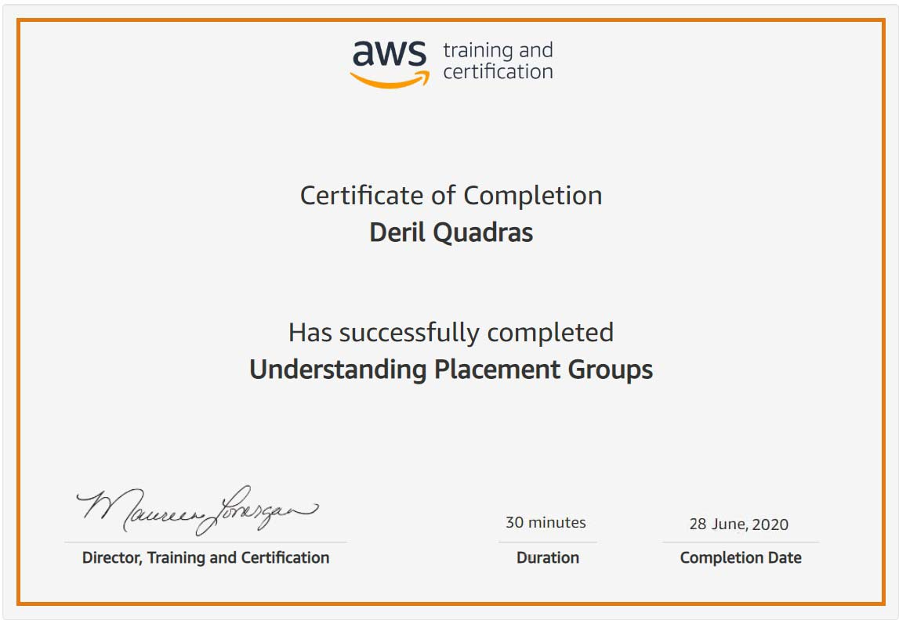

Coding Challenges Details:

**PROGRAM 1 .**

**//string comparision without using builtin function**

**#include <stdio.h>**

**#include <string.h>**

**int main()**

**{**

**char Str1[100], Str2[100];**

**int result, i;**

**printf("\n Please Enter the First String : ");**

**gets(Str1);**

**puts(Str1);**

**printf("\n Please Enter the Second String : ");**

**gets(Str2);**

**puts(Str2);**

**for(i = 0; Str1[i] == Str2[i] && Str1[i] == '\0'; i++);**

**if(Str1[i] < Str2[i])**

**{**

**printf("\n str1 is Less than str2");**

**}**

**else if(Str1[i] > Str2[i])**

**{**

**printf("\n str2 is Less than str1");**

**}**

**else**

**{**

**printf("\n str1 is Equal to str2");**

**}**

**return 0;**

**}**